Spring Newsletter 2016 (no 52)

Chairman’s Welcome

It was lovely to see so many of you at the recent Cheese and Wine evening. A very convivial evening was enjoyed by all, and it was a chance to update members on progress made with the ‘Europe in Harmony’ choral festival and to say thank you to our sponsors and those who have helped with fund-raising.
As you can read in this newsletter, plans for the event are progressing well, and the organising committee has done a sterling job in putting on an exciting choral programme and in generating the funds to host this event in style. I am looking forward very much to welcoming representatives from Chantilly, and from Uberlingen and Watermael-Boitsfort to our town in June, to our communities coming together to enjoy a common pursuit with friends from other communities - which is what twinning is all about.
Our guests from the three towns have all indicated a strong wish to enjoy home hospitality. We have had many generous offers of accommodation so far, for which we are grateful. However as you can read in this newsletter we are still some way short. If you are able to offer a room for a couple of nights, please do get in touch with Anne Richardson, whose details are in the newsletter.
With slightly unfortunate timing, a few weeks before the choral festival, the country will take part in a referendum on whether to leave or remain in the European Union. I suspect that as an Association we may have differing views on this topic. But we have, I am sure, one thing in common. That whatever the result we are determined to continue our efforts to promote the benefits of twinning and to enjoy even closer ties with our long-standing friends in Chantilly. Inside or outside the EU, twinning will survive.
I was very sad to hear about the passing of Reg Saviel, a former councillor, Alderman and stalwart of the twinning committee in its early days. It was only two years ago that I presented Reg with a memento to mark his appointment as Life Vice-President of the Town-Twinning Association. I did not know him well, but many of you who did have told me what a wonderful man he was. He will be sadly missed and our condolences go to his family.
The AGM of the Town Twinning Association is on Tuesday 7th June at the Town Hall, details inside. I hope as many of you as possible will attend, and I look forward to seeing you then.

Cllr Clive Woodbridge, Chairman
Chantilly Christmas Market – 12-13 December 2015

As usual Richard and Anne were stirring up in November, producing some 70 Christmas puddings. At the same time another group, including Anna Deavin and Jill Preiss, were baking literally hundreds of mince pies, and Margaret Angus and Ros Godson were baking and decorating mini Christmas cakes, a new experiment. All of this was in aid of the Chantilly Christmas Market, and on the Friday morning, cars were loaded and Deavins, Richardsons and Thorleys set off. Conveniently, after having arrived at the Chantilly racecourse and set up our stall, it was cocktail time and we were invited to Anne and Charlie Peck’s for Champagne and Kir. We were joined at dinner in l’Avenue by Chris and John Lewis, completing a strong team.
The Lewises had brought Stilton with them, together with some sweet Conference pears, and this innovation surprised the French who could not believe that the British could make such a high quality cheese (one lady insisted that we were lying and it was Roquefort in disguise). We were visited by the Mayor, M. Woerth, and many twinning friends. Our contingent included three Rotarians, so our stall was visited by several members of Chantilly Rotary Club and we took advantage of the lunch provided at the Inner Wheel stand.
Dinner on Saturday was a convivial affair for all twinning stall holders at a local school, and we parted with promises to meet again this June/July for the choral festival here in Epsom. As usual we more or less sold out on Sunday and therefore had room for the champagne, foie gras etc. which we had bought from the many produce stalls. Oh, and I bought Diana an umbrella.
As a result of the trip £500 was contributed to Twinning funds.
Richard Deavin, Epsom Rotary

OBITUARY – Mr Peter Brandt

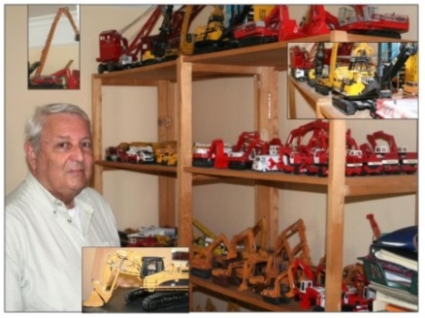
Peter Brandt was a very good friend to Margaret and I, and to many people involved in Chantilly’s several twinnings. We were very sad to leave after seeing him in poor health at his flat during the 20th Anniversary weekend. Peter was at home in the languages of France, England, Germany and Belgium and was always on hand to ease communication throughout those two decades. Adopting his quiet, modest and slightly-less-than-official attitude he was a major factor in the success of many special visits, working hard to ensure we all knew “Wheres and Whens”. We enjoyed staying in each other’s homes and we will miss having Peter as our first point of reference on arrival in Chantilly. A few of us were fortunate to see his collection of unusual model vehicles ranging from earthmoving ‘Caterpillars’ to cranes which reached up to the ceiling.
Our last contact was to deliver a ‘Good wishes’ card signed by the Mayors, Councillors, and friends from Chantilly and Epsom & Ewell. Brian Angus, Founder member
A TRADITIONAL BURNS SUPPER

Fifty-four guests, including the Mayor and Mayoress of Epsom & Ewell, Councillors Chris and Liz Frost, attended the Twinning Association’s Burns Supper which was held on Saturday 30 January 2016.
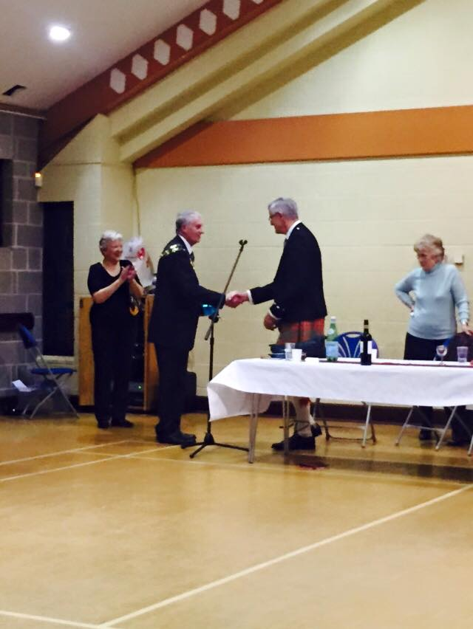
The evening comprised a traditional three-course Burns Supper with all the attendant toasts and speeches, not to mention the obligatory dram of Scots whisky! Clive Richardson was a splendid Chairman for the evening’s activities and went to great lengths to explain to the assembled Sassenachs the history behind the celebration of the anniversary of Rabbie Burns’ birthday.
We were delighted to welcome Ian Hay to toast the arrival of the haggis and also to propose the Immortal Memory. We were also privileged to have Paul Smy give us a delightful rendition of My Love is Like a Red, Red Rose, one of Burns’ most beautiful love songs. There were definitely one or two ladies with tears in their eyes!
Many thanks are due also to Clive for his “Toast to the Lassies” and to Margaret Nightingale for responding on their behalf. To finish the evening in appropriate style, Celia Chapman called the company through a selection of Scottish country dances.
Guides from the 12th Epsom Guide Company supplied the waitressing and serving for the evening, and as well as their fee were delighted to receive £160 in a retiring collection towards the building of their new Lodge at Little Acres Camp Site.
Many thanks to all who attended the event, which raised funds for the forthcoming “Epsom in Harmony” choral festival. By all accounts everyone thoroughly enjoyed the evening and we raised in excess of £900.
Carol Thorley, Founder member

My trip to Chantilly - linked to the Rotary Club

This visit came about as a result of the Rotary French Public Speaking Competition last year when Daniela was a competitor, but it was set up by the Twinning committees here and in Chantilly. The people she stayed with are members of Twinning.
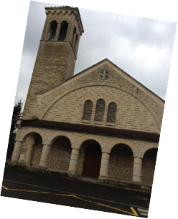
Here is Daniela’s article:

On the 13th February I was kindly invited to spend a week in Chantilly, France with a host family. In addition, the main purpose of my trip was to improve my French speaking and orally have a better chance of succeeding in my French A level. On the day following my arrival I went to the town church for Mass for the beginning of Lent, and then I joined the other volunteers and delivered church newspapers.
During my stay, I went to several places, such as the famous Castle of Chantilly where Le Duc d’Aumale lived - and during my tour of the castle I learnt a lot about the history of Chantilly (twinned with Epsom). The castle comprised many famous and incredible paintings and statues, it was also interconnected to many vast and lusciously green gardens and lakes where a variety of animals such as swans were seen.
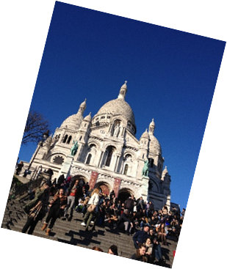
On the Tuesday we went to Montmartre, and we visited many other beautiful churches on our walk, (and had lunch at a typical French restaurant, which served delicious food) - however none compared to the sheer beauty of Le Sacré-Cœur.
Nonetheless I cannot deny the fact that we were immensely exhausted after having climbed 300 steps to reach the top of the church, but the view on Paris made the journey worth it!
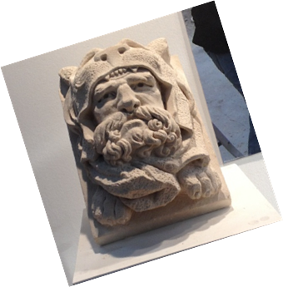
Then on Thursday we went to a quarry called ‘La Maison de la Pierre’. The quarry is very famous as the stone in it has been used to create many astonishing landmarks such as the Great British Museum (the stone is called ‘La Pierre de Saint-Maximin’). Not only did I visit many wonderful places, I tried a variety of new and traditional French meals including ‘La Raclette’ (melted cheese trays) and typical charcuterie and soups (like the Potage - tomato soup). I was privileged to stay with a very lovely and welcoming couple; and two of their grandsons also came to stay with them during this time who were from Rouen.
We all got on really well so I was able to really enjoy my trip. I became fond of them so did feel quite sad to leave them and take the Eurostar back home on the 20th February. This was an experience I will never forget. Personally I have become more confident in speaking French on a daily basis. We are still in contact and I hope that either they will visit me in England or I will see them again in France.
Daniela Bouferrache, Rosebery School

Fund-raising Quiz Night

A packed United Reformed Church hall was the scene for the Twinning Quiz night held on 5 March. Ten teams of around 7 contestants fought out an exciting evening of questions. The mandatory fish and chips supper provided sustenance and guests brought their own drinks. Questions ranged from musical (what European city does this music bring to mind) to questions about Epsom (such as what is the name of the gardens open to the public at the bottom of Downs Road)?
Overall we raised £400 for the Choral Festival funds which we were very pleased with.
Clive Richardson, Epsom Rotary
A day in Lille

Every two years over a Spring weekend a prestigious model railway exhibition is held in Lille. As I missed the exhibition in 2014 I was determined to go this year.
Le Weekend de Modèle Ferroviaire à Lille was held on 5 and 6 March. I had booked a favourable fare on Eurostar from St Pancras. Saturday was a very cold day but the sun shone. I was accompanied by four other members of Wimbledon Model Railway Club, including fellow Twinning member Trevor Taylor. All of us are French speakers which added to the enjoyment. Being only 90 minutes the train journey was no hardship.
We walked from the station at Lille Europe into the city centre, passing through the traditional station at Lille Flanders. We continued along the Rue Faidherbe to the Opera, the Chambre de Commerce and the Vielle Bourse, admiring the Flemish architecture whilst at risk from "segregated traffic". At a restaurant on the edge of the Place Rihor we enjoyed an excellent lunch. The Tourist Information building was interesting being part of the old Palace of the Ducs de Bourgogne constructed in the XV century by Philippe Le Bon.
The city centre was crowded being a Saturday, but I was surprised that the "grand magasin" Galeries Lafayette, opened with such fanfare in 2007, was an empty building!
For those with an interest in public transport, Lille boasts the first automatic metro system in Europe, a tramway and a free bus around the city centre. As railway enthusiasts we had to sample the Metro which bore a resemblance to the Victoria Line in the rush hour. It took nearly as long to walk from the station at Gambetta to the exhibition hall as from the city centre. The exhibition was held in the Salle de Gymnase. We were almost the first visitors but the hall soon filled. Everyone made us very welcome and we spent the afternoon speaking French, not only because it was polite but few of the exhibitors spoke English. In the best twinning tradition we made some excellent contacts and look forward to a return visit in 2018.
We walked back to the city centre through a large square containing the Prefecture and the Musée des Beaux Arts. A statue of the formidable Général Faidherbe stood guard at the entrance to the pedestrianised Rue Bethune, his drawn sword a deterrent to the terrifying groups of youths thronging the pavement. We took refuge in a tea room frequented by families buying bread, cakes etc. When we emerged it was raining, and still cold as we returned to the station, but it was a very enjoyable day out.
Peter Hardy, Committee member

Cheese and Wine Party – 17 March

About 40 members and friends attended our annual Cheese and Wine evening at the Town Hall. The Mayor of Epsom and Ewell, Cllr Chris Frost, attended with the Mayoress, Cllr Liz Frost, and our other guests included representatives of key sponsors of our choral festival, “Europe in Harmony”: Steve Whiteway, MD of Epsom Coaches, and Alice Jordan and Kirsty Manley from TWM.
Our Chairman introduced the Mayor, who as Hon President of the Association welcomed everyone. Steve Whiteway spoke about Epsom Coaches’ ongoing commitment to support the local community, and Jon Pullinger from the Festival Steering group outlined the plans for the festival performances. Clive Woodbridge concluded by referring to the festival’s ongoing need for the support of the Association, especially in terms of accommodation for our visitors and support at the remaining fund-raising events.
Alison Chatterton and Anne Richardson had provided an excellent selection of French cheeses (with at least one surprise) and some other delicacies, and I had done my best to procure some reasonable French wines which seemed to go down well!
Thanks are also due to the usual stalwarts, Clive, Margaret and Diana who ensured that the evening went smoothly, and we returned some £300 to funds.
Richard Deavin, Epsom Rotary
Les Soirées Françaises



Our regular Soirées are well attended - both beginners and advanced seem happy with the format – we do crosswords, read magazine articles, and practice French in sympathetic surroundings. Do bring your own ideas, and if you would like to host one of these evenings please contact Margaret or Anne.

Our next conversation evening will be on Monday 4 April at 7.30pm chez Margaret, Flat 4, Christchurch Gardens, Christchurch Mount, Epsom Surrey KT19 8RU.

Do join us for easy French conversation, a glass of wine and a snack or two. Cost £5 per head. Please RSVP to mcnightingale@sky.com or tel 01372 602560.

Anne Richardson, Membership Secretary

French Breakfast
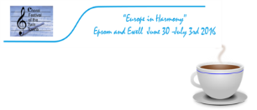


Clive and Anne Richardson invite you to a

Fund-Raising French Breakfast at Madan Cottage, Avenue Road, Epsom, in aid of the 2016 Choral Festival, on Sunday 10th April.
We will be open from 9am until 12.30, with food ranging from coffee and a croissant, European cold meats and cheeses, for £7, to a full ‘English’ for £10 (Clive’s special).
You are welcome to bring friends and family. Please RSVP so that we can cater accordingly. tel 01372723698 anne.richardson@btinternet.com
Anne Richardson, Membership secretary

Fashion Show

Riche of Ewell Village invite you to a Fund-raising Fashion Show to be held at Christ Church Hall, Cheam Road, Ewell on Tuesday 19th April at 7pm.
Tickets priced at £10 to include a glass of wine and nibbles on arrival can be booked through me at Margaret@epsomtwinning .com or tel. 01372 602560.
So ladies, please bring your friends and neighbours.
As well as showing us some beautiful clothes on the catwalk, Carol will also bring some displays of jewellery and other fashion items for you to browse. We look forward to a fun relaxing evening.
Margaret Nightingale, Secretary

Members’ Dinners


We have a growing group of members who enjoy meeting socially and catching up with the latest twinning news at our regular dinners. If you haven’t come to one yet, please be assured of a warm welcome.
Our next meal will be on Tuesday 17 May at the Neapolitan Kitchen in Ewell Village. More information and menus will be sent to members in due course, but meanwhile please put the date in your diary.
Anne Richardson, Membership Secretary

Twinning Association AGM – Tuesday 7 June

Our Annual General Meeting will be held at the Town Hall, Committee Room 1, on Tuesday 7 June 2016 at 7.30pm. The official notice and agenda will be sent to all members well in advance, but please make a note in your diary now.

Do not think of an AGM as boring - it is an opportunity for you to gather with other members, and over a glass of wine to hear reports on our activities over the past year, and also our plans for the future. So do please come, as this year has been challenging for Epsom, as we will be hosting the Choral Festival of the Twin Towns in July.

Margaret Nightingale, Secretary

Three Lions make their home in Chantilly - and will be joined by EEFC

As many of you will be aware, the England football team will be making Chantilly their base for the forthcoming European Football Championships which are being held this year in France. The team will stay at the luxurious Auberge du Jeu de Paume hotel, owned by the Aga Khan, while they prepare for and take part in the tournament, which is second in importance only to the World Cup.
The decision has created an exciting opportunity for a twinning contact, as Epsom and Ewell Football Club (EEFC) has been invited to travel to Chantilly to take part in a small tournament with players from our twin town. Around 25 senior players, management and supporters will make the short journey across the Channel and will stay in Chantilly between 17th and 19th June. It is hoped that they will be able to take part in a training session with players from the England squad, although that is not confirmed as yet.
We wish them well and hope this will be the start of close contacts between our two football teams. We also hope that England does well and gets to enjoy the delights of Chantilly right through to the final in Paris on July 10th!
Cllr Clive Woodbridge, Chairman

Choral Festival of the Twin Towns – 30 June-3 July

Europe in Harmony
Many of you will have already heard the latest on our preparations for the choral festival in the summer, but here is a quick overview.
Sponsorship: With help from our very generous sponsors, we are assured of our basic funding and are now moving ahead with our plans. Special thanks are due to key sponsors Toyota, Epsom Coaches, the Humphrey Richardson Taylor Charitable Trust, Surrey County Council thanks to our local councillors, and Clock House Healthcare, not to mention the very many who are giving us generous practical support. We will be continuing with just a few more fund-raising ventures between now and July.
Festival Performances: The music team, headed by Janee Foxon and Jon Pullinger in conjunction with Justin Lavender, our Musical Director, has put together a great programme of classical English and European repertoire, interspersed with different styles and genres from the variety of choirs and countries represented at the festival, as follows:
- Thursday 30 June - Schools singing in the town centre in the afternoon, and, in the evening, a performance at the Methodist Church by local choirs.
- Friday 1 July – Concert hosted by St Martin’s Church performed predominantly by local choirs.
- Saturday 2 July – Civic reception at the Playhouse and singing around the town centre. Evening gala concert at Epsom College featuring the visiting choirs, and a special programme in which they will be joined by a combined festival chorus of 100+ voices from the local choirs and Epsom and Ewell Silver Band.
- Sunday 3 July – Visitors depart all too soon, but we hope for some more singing and other entertainment before that happens, possibly in Ewell.
Prior to the above, there will be a build-up of activities in the Ashley Centre to promote the festival and raise awareness of twinning. We will be looking for a team of twinning veterans to man the information points and talk to passers-by.
Of course there are many things yet to plan such as the logistics of the weekend, making sure everyone is in the right place at the right time, recruiting volunteers for the many support tasks, like stewarding at the concerts, guiding and translating for visitors and providing refreshments for the singers, not to mention accommodating around 120 visitors. Many of you have already volunteered, but if you are still thinking about it, please get in touch with me or Anne Richardson as soon as possible.
Thank you once again for all your support, helping with and attending the many events we have held in the past 12 months. The result speaks for itself – and we could not have done it without you!
Diana Deavin, Vice Chairman and Festival Coordinator
01372 727382 07778 935341 diana.deavin@yahoo.co.uk

EPSOM FUNDAY – Sunday 18 September

The Rotary Fun Day will be held in Horton Country Park on Sunday 18 September. This event has become a major showpiece for charities in our Borough. Although not primarily a fund-raising event, the publicity generated is enormous as a large number of visitors is expected.
It is our intention to have a twinning stand at the Fun Day again. As the name suggests the event is all about "fun" and we seek to entertain the public with games whilst at the same time drawing attention to the principles of Twinning. In fact the Fun Day has been an important source of recruitment and making contacts.
In addition we seek further ideas for 2016. Also any members who may be able to help will be very welcome. You need not attend for the whole day, an hour or so would be very useful. It is fun too for the stall holders. Whilst the weather cannot be guaranteed, in the past we have been rewarded by warm late summer sunshine.
So please put the date in your diaries!
Peter Hardy, Committee member

Calendar of Future Events
2016
Monday 4 April | Soirée Française chez Margaret
Sunday 10 April | Breakfast at the Richardsons
Tuesday 19 April | Fashion show at Christchurch Hall, Ewell
Monday 9 May | Soirée Française chez Anne
Tuesday 17 May | Members’ dinner at the Neapolitan Kitchen
Saturday 4 June | Derby Day Party in Margaret’s garden
Tuesday 7 June | Association AGM at the Town Hall
Friday 10 June | Champagne Tea at Barbara Warwick’s
Friday 17 – Sunday 19 June | Epsom & Ewell Football Club in Chantilly
Thursday 23 June | European Union Referendum
Thursday 30 June – Sunday 3 July | Choral Festival of the Twin Towns in Epsom
Sunday 18 September | Rotary Fun Day at Horton Country Park

Committee for 2015/16

Cllr Clive Woodbridge – Chairman 0208 3932853
Mrs Diana Deavin – Vice-Chair/Liaison Officer 01372 727382
Mr Brian Vandervilt - Treasurer 0208 3958996
Mr Brian Atkinson – Assistant Treasurer 01372 723767
Mrs Margaret Nightingale – Secretary/ Newsletter Editor 01372 602560
Mrs Anne Richardson – Membership Secretary 01372 723698
Mrs Alison Chatterton 01372 811099
Mr Cyril Frazer 0208 3933628
Mr Peter Hardy 01372 721148
Mr Martin Lewis – Publicity Officer 0208 3933877
Cllr Keith Partridge 01372 740602
Mr Norman Shipley 07903 544546

Representatives of Local Groups supporting Twinning

Mr Harry Corben – Epsom Civic Society
Mr Richard Deavin – Epsom Rotary
Ms Janee Foxon – Sponsalia Chamber Choir
Mr Cyril Frazer – Epsom Male Voice Choir
Mr Colin Peel – Epsom Rotary
Mrs Jill Preiss – Epsom Choral Society
Mr Frank Warren – Epsom Model Railway Club

